**STEPS**

1. Open the Microsoft Visual C++ 6.0
2. Click on the File menu option and a new dialog box is opened
3. Select the “Win32 Console Application” from the new dialog box
4. Type the name into the Project name box
5. The path for the project name box given into Location box
6. Click OK button in the new dialog box

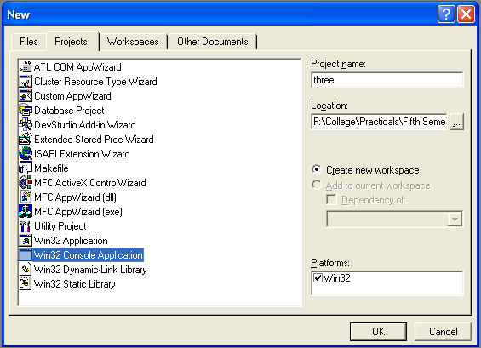

1. Click on the File menu option and a new dialog box is opened
2. Select the C++ Source File entry and give the file name .cpp in File name box
3. Check that “Add to project” is checked
4. Click OK button
5. Select the “Build one.exe” item in the Visual C++ build menu and compile the program
6. Select the “Execute one.exe” item in the Visual C++ build menu

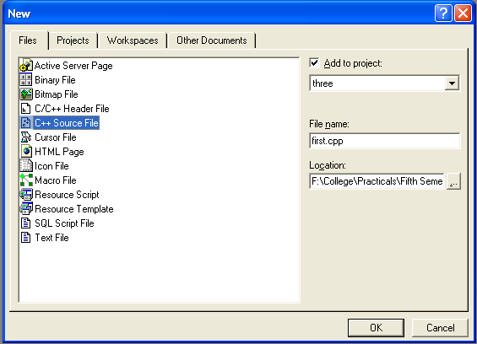

**CODING**

#include<iostream.h>

#include<conio.h>

class volume

{

float e,r,h;

public:

void vol(float);

void vol(float,float);

};

void volume::vol(float e)

{

float c;

c=e*e*e;

cout<<"Volume Of Cube="<<c<<"cb cm"<<"\n\n";

}

void volume::vol(float r,float h)

{

float c;

c=3.14*r*r*h;

cout<<"Volume Of Cylinder="<<c<<"cb cm"<<"\n\n";

}

int main()

{

volume v;

int choice;

float a,b,c;

cout<<"\t\t\t--:Volume Of Geometrical Shapes:--\n";

cout<<"1-Volume Of Cube\n";

cout<<"2-Volume Of Cylinder\n";

cout<<"Enter Choice=";

cin>>choice;

switch(choice)

{

case 1:

cout<<"\nEnter Edge Of Cube=";

cin>>a;

v.vol(a);

break;

case 2:

cout<<"\nEnter Radius Of Cylinder=";

cin>>a;

cout<<"\nEnter Height Of Cylinder=";

cin>>b;

v.vol(a,b);

break;

default:

cout<<"Enter Right Choice\n\n";

}

return 0;

}

**OUTPUT**

